Lesson 5 Homework  FRONT PAGE | LT 6.2, 6.3, 6.4 | 14-16, 18, 19, 26-28 (FRONT PAGE)  4-11, 14, 20, 23, 24 (BACK PAGE)

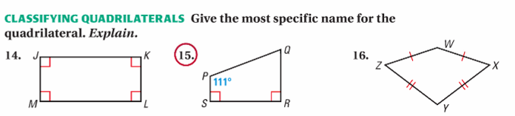

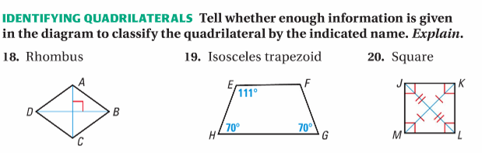

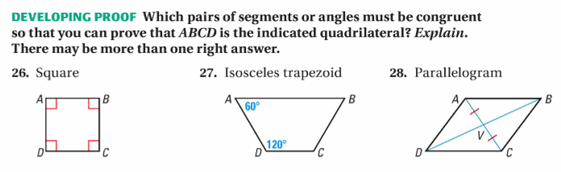

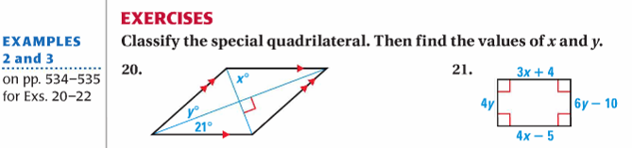
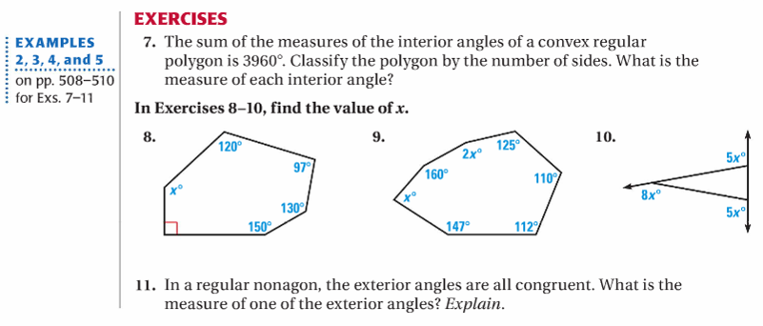
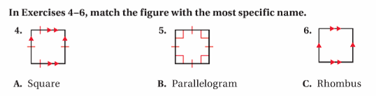
Lesson 5 Homework  BACK PAGE | LT 6.2, 6.3, 6.4 | 14-16, 18, 19, 26-28 (FRONT PAGE)  4-11, 20, 23, 24 (BACK PAGE)

